Meeting Minute with Nancy 10 March
Project duration: Jan 1, 2026 to Dec 31, 2028
Personality measurement: Big Five, MBTI, Type A/B(acute and relaxed), proactiveness

Idea 1
HCI, Parasocial relationship, anthropomorphic agent
Pretest- (1) proactiveness test; (2) neurodiversity inclination test (types of visual content- colour, figure/text/picture/sound, intensity, speed, length of attention)
Experiments:
Experiment 1A- Task based experiment- lab or online AI-assisted learning experiments (response data, test data+ online camera eye-tracking data)
Experiment 1-B- interactive experiment-dark side of proactiveness
In group learning dynamic- proactiveness + control+ aggressiveness= self achievement + conflict
Post test: self-efficacy, learning effectiveness (LOs), learning wellbeing

Theoretical base: First impression theory, halo effect theory
Theoretical contribution?

Buy samples from Prolific or Credamo
Experiment 2- field experiment- in the real training, wearable eye-tracker, for attention pattern and their personality/neurodiversity traits

Skill requirements:
Technopychology, experiment, eye-tracking, Python
To have a test dataset to try

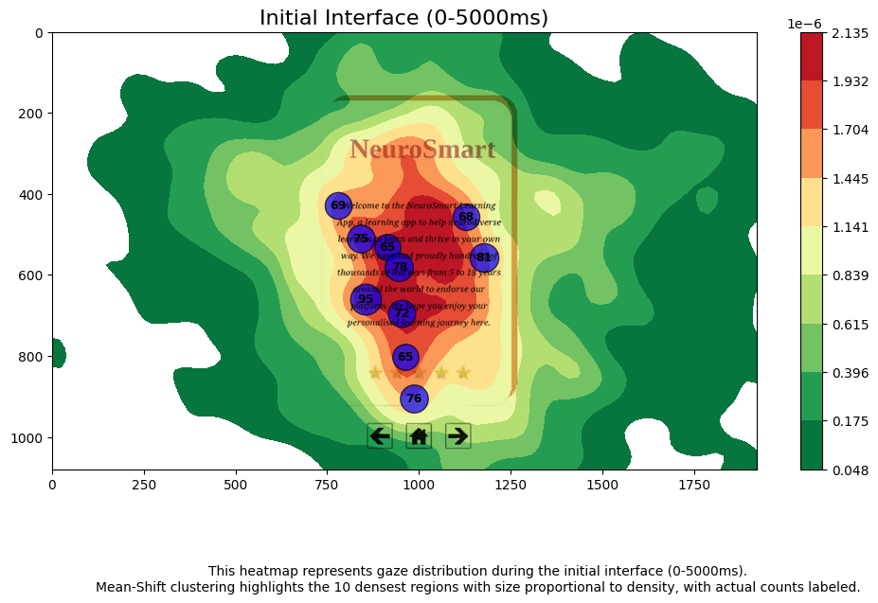
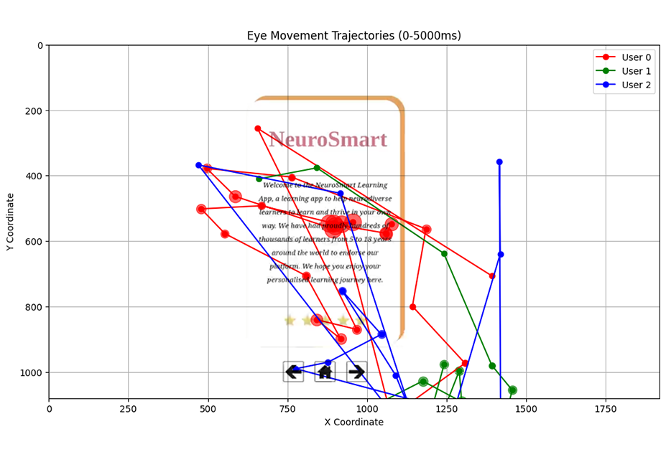
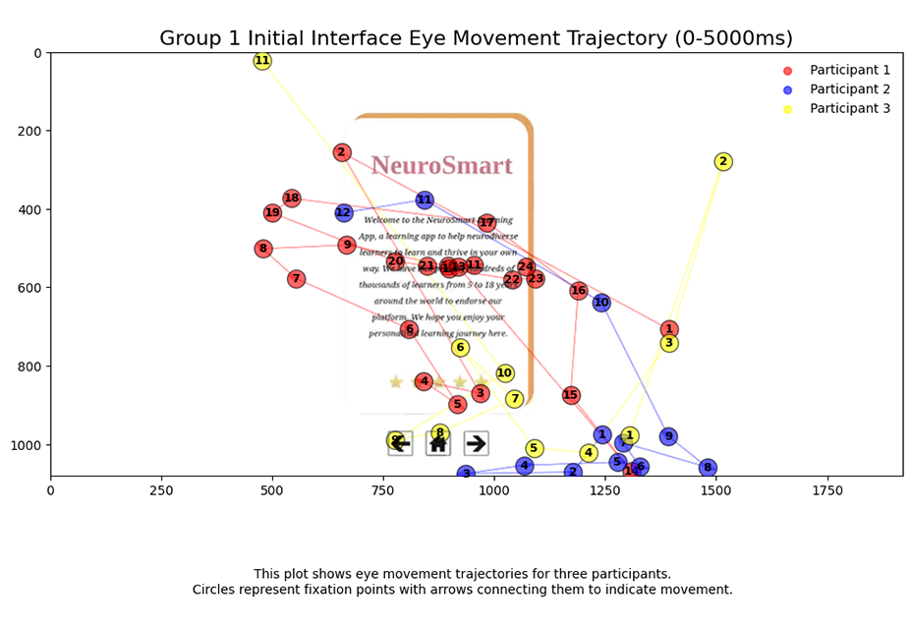
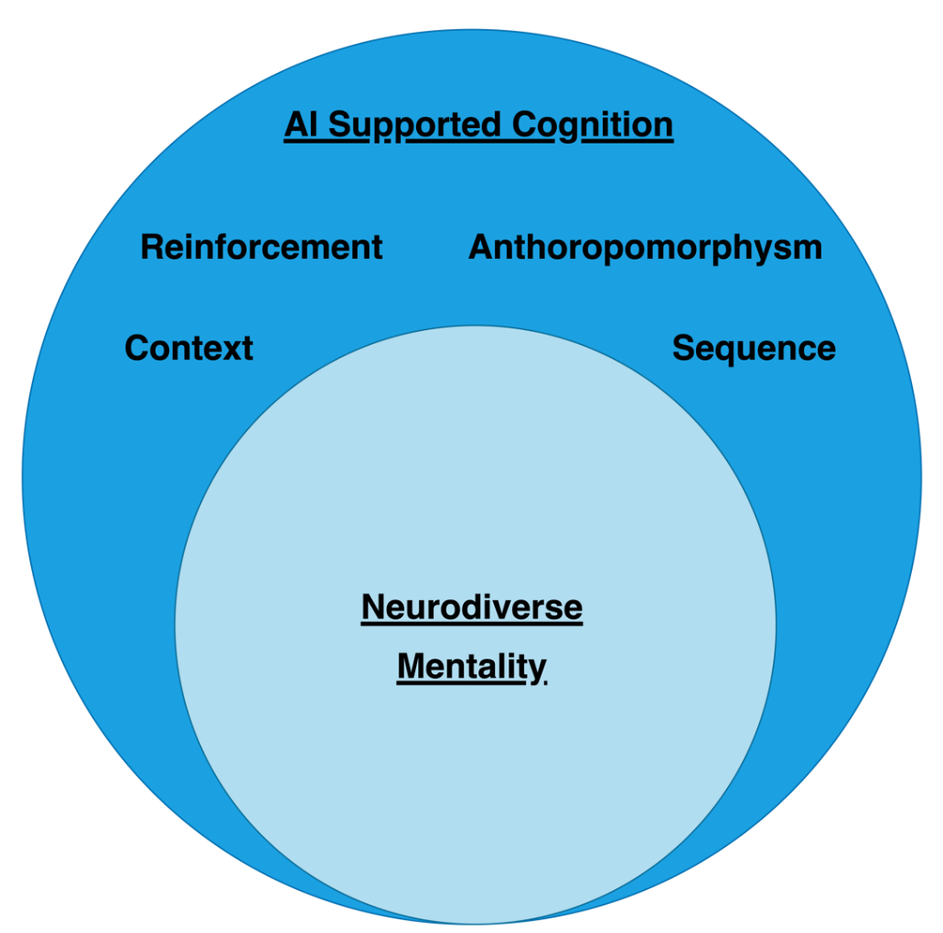

Idea 2
Conference core video- road show/Nasdaq listed companies
Analyse the persona in video (proactiveness+ appearance-care/fashion) or published photo images in company website, Linkedin, and Facebook, and their relationship with company’s financial performance, ESG performance, and if these linkages varied in traditional versus emerging industries

